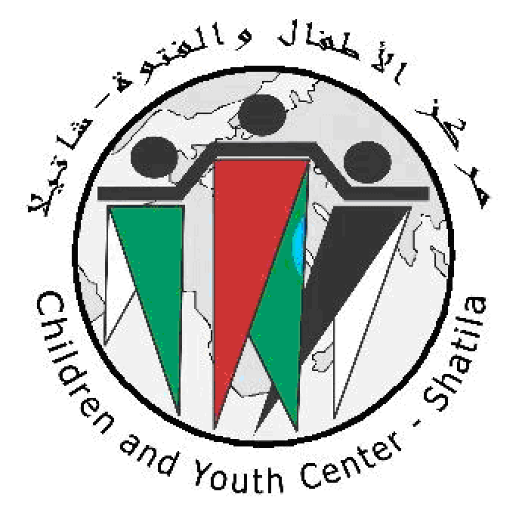

On the occasion of 69 aneversay of Al Nakba 1948
&
Support to the Hunger strike of the Heroic prisoners in the Zionist prisons.
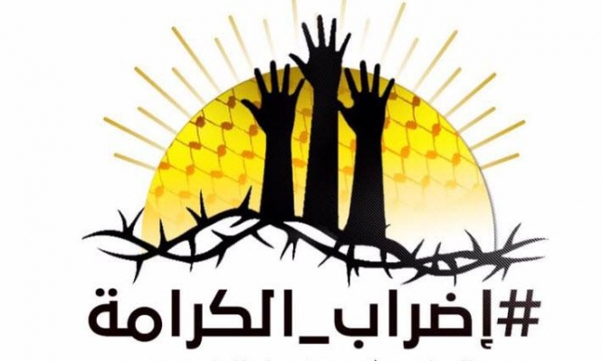
Children & Youth Centre is pleased to invite you to the Cultural and Artistic Festival

Monday 22 May 2017 at 5:00 PM
P lace: In front of the Solidarity Tent and CYC-Shatila

