In Pictures: Clowning around in Lebanon camps
Volunteer clowns from Belgium's 'Clowns Without Borders' entertain children in Lebanon's refugee camps.
Melinda Trochu
Last updated: 24 Apr 2014 10:47
As they walk through the Shatila refugee camp in Beirut with a stampede of children at their feet, Kevin, Geraldine, Francoise and Virginie sing and smile at the incredulous locals. These Belgian clowns are in Lebanon for a month to play for Syrian, Palestinian and Lebanese children in the refugee camps.
Today, an estimated 500,000 Syrian children are living as refugees in Lebanon, and most don't attend school.
The clowns are volunteering with the association "Clowns and Magicians Without Borders", founded 10 years ago in Belgium. At the end of this trip, they will have visited the Bekaa, Tripoli, Beirut and even southern Lebanon, home to the famous Shebaa farms. On April 30, the troupe will play its last of 40 performances in Lebanon.
They will then travel to Afghanistan to once again turn their motto - "Laughing is the shortest distance between two people" - into reality.

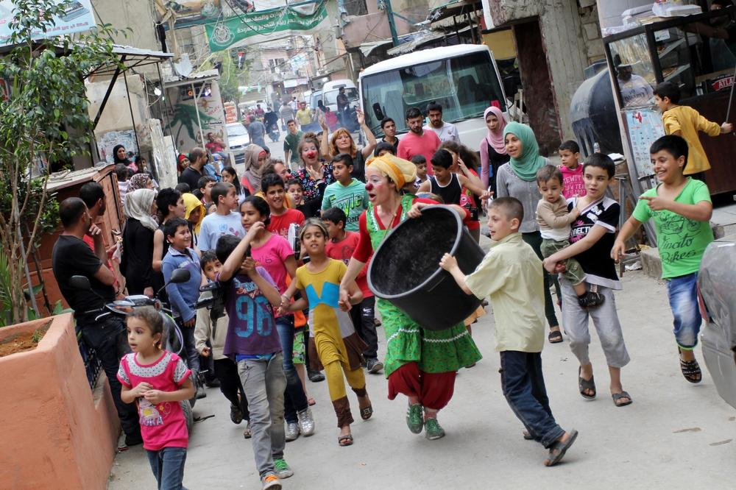
Melinda Trochu
The clowns paraded through the streets of the Shatila refugee camp with children and other camp residents.

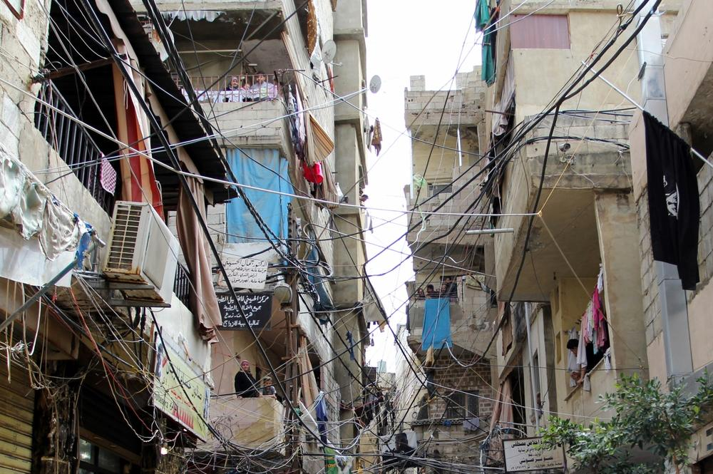The Shatila refugee camp in southern Beirut was created in 1949 after the expulsion of Palestinians from their homeland. It is an overcrowded camp with around 20,000 people per square kilometre. The camp suffers from lack of space, water and electricity.

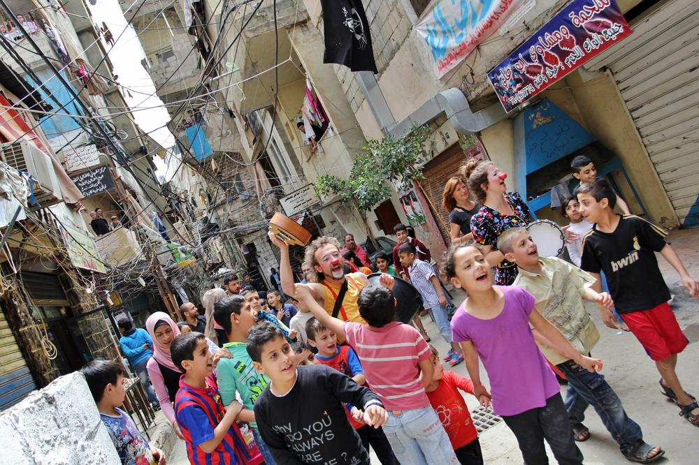The clowns travel with few materials. They make the children laugh with a basin, ropes, plastic bags, a large umbrella and of course, their red noses.

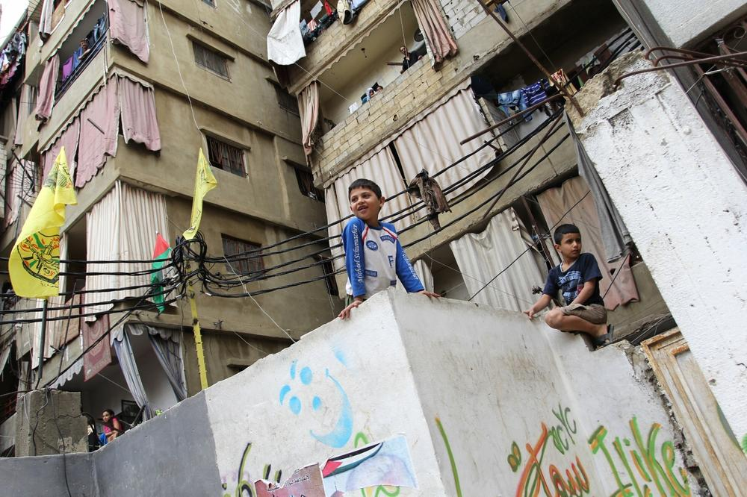More than half of the one million registered Syrian refugees in Lebanon are children. Among these children, 310,000 are currently not attending school, according to the UN refugee agency (UNHCR). Instead, they wander the alleys of their camps.

The clowns performed in the library of the camp's Children and Youth Centre.

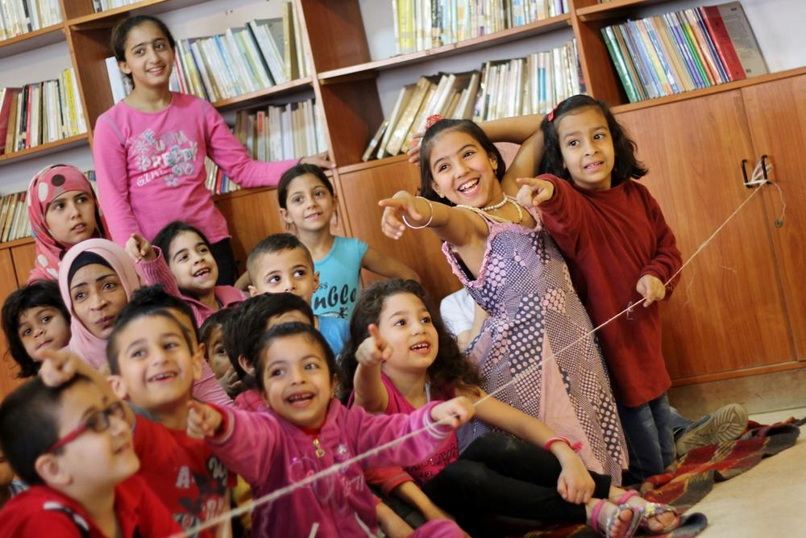
Melinda Trochu
Around 100 children attended the clowns' show.

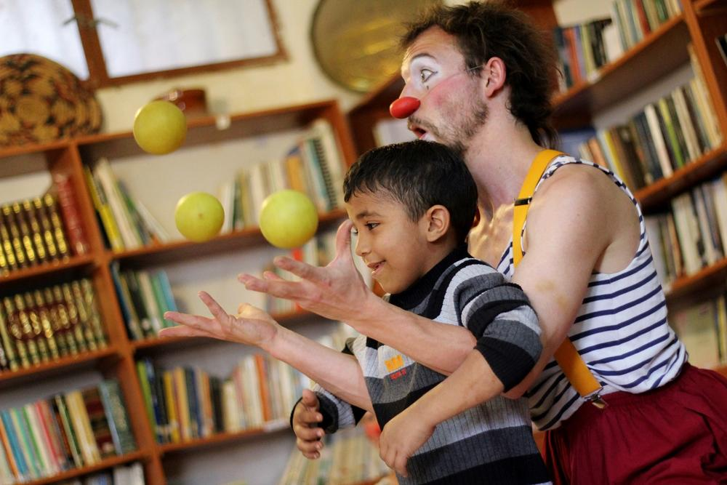
Melinda Trochua
The clowns try to involve the kids in their acts as much as possible.

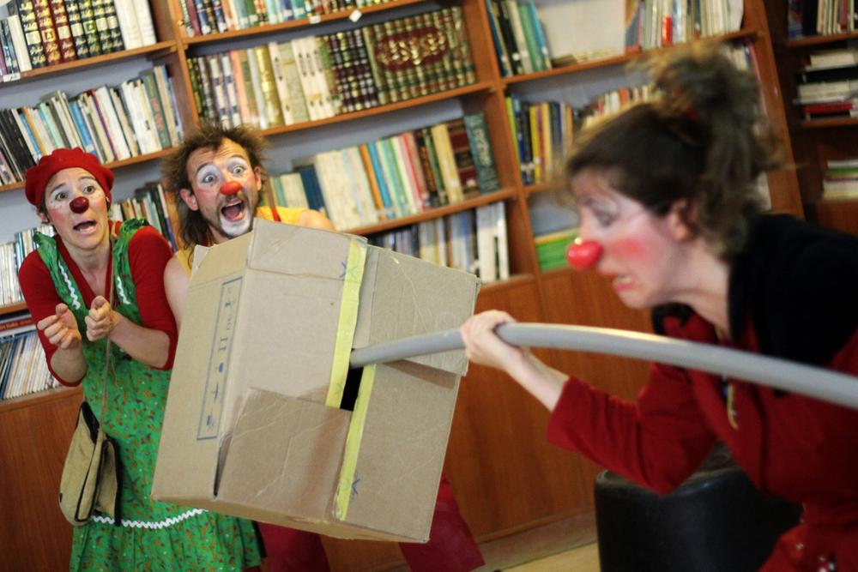
/Melinda Trochu/Al Jazeera
The NGO "Clowns and Magicians Without Borders" is active in several countries. Originally from Belgium, the clowns are all volunteers.

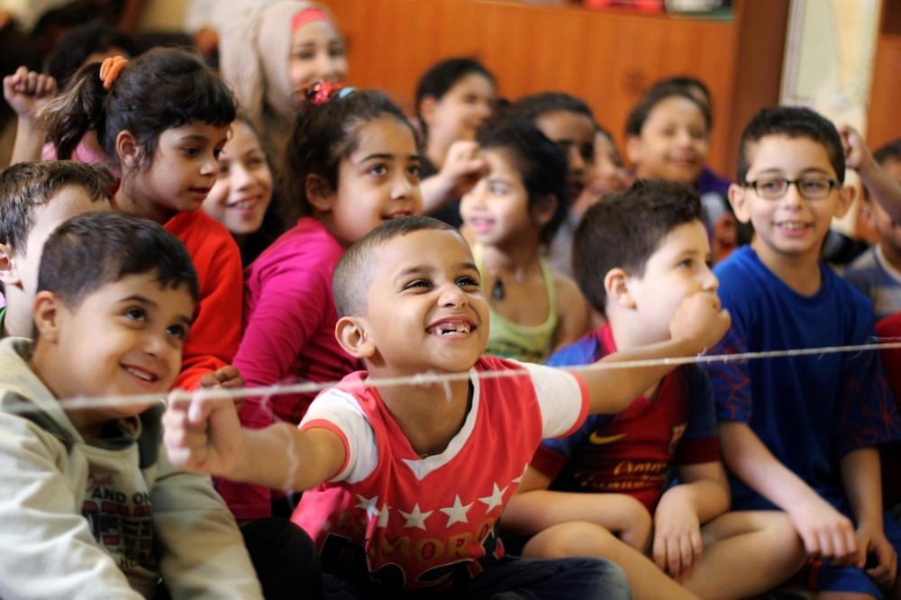
Melinda Trochu
Abu Moujahed, director of the Children and Youth Centre, said that the main purpose of hosting the clowns is "to make [the children] happy, because in Shatila they suffer a lot".

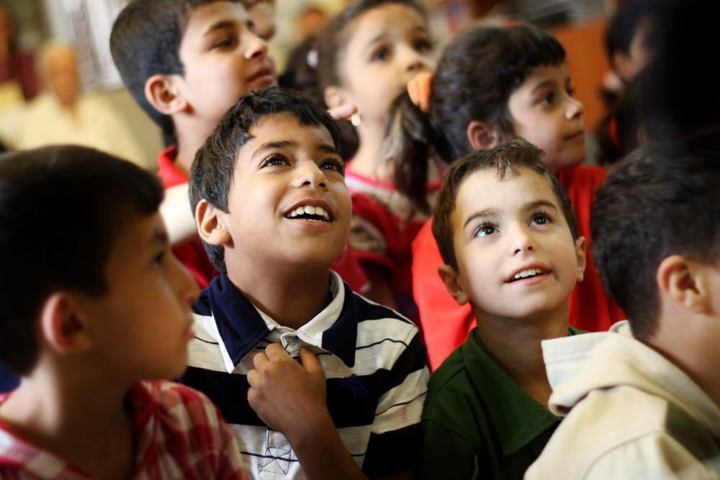
Melinda Trochu
"When we go somewhere, we want the kids to forget that they are hungry, afraid, thirsty," said Francoise, one of the clowns. "Most of all, we want to remind them that they are just kids. And that they have the right to dream."

