Children and Youth of the Nahr el-Bared Camp Grow and Learn as Camp is Rebuilt
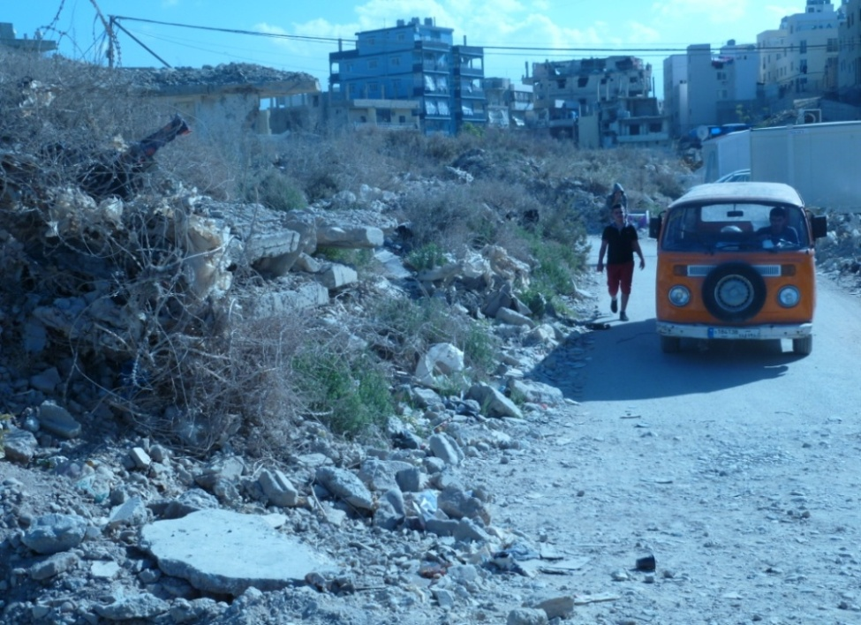
Palestinian refugee families currently living in the Nahr el-Bared camp in north
Lebanon have had to struggle with a host of difficult conditions.
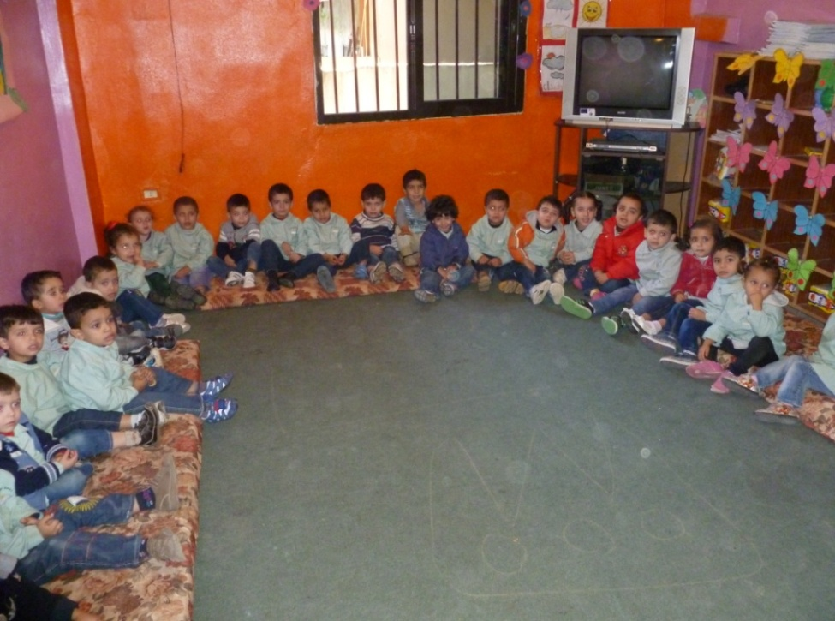
In 2007, the camp was completely destroyed by the Lebanese army. Nearly 7 years
later the camp is only about 30% rebuilt, while about half of the previously displaced
population has returned to new part of the camp that is now extremely overcrowded.
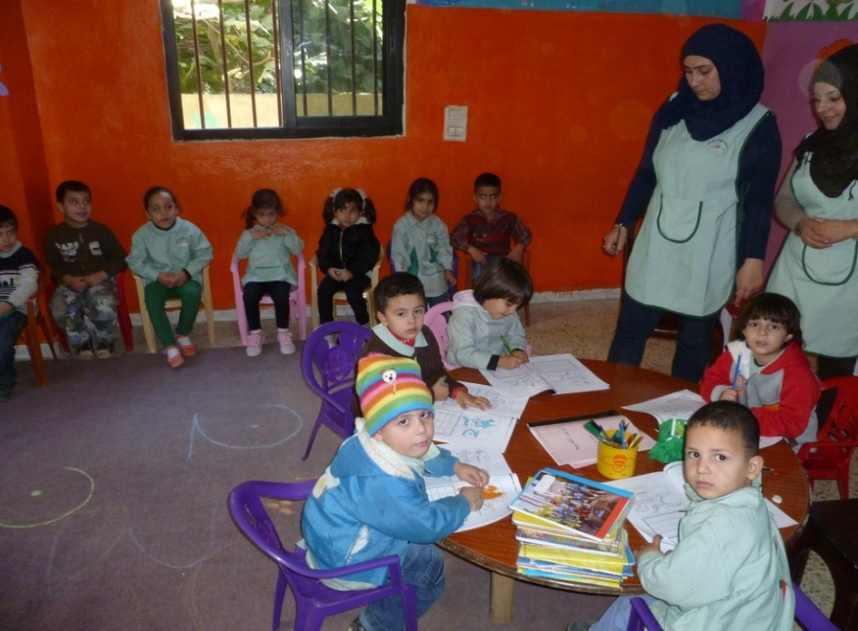
In addition, consistent clashes between rival neighborhoods in near-by Tripoli,
tied to the war in Syria, have limited the freedom of movement of camp dwellers,
making it even more difficult for the refugees to find and secure employment
among the narrow set of jobs they are permitted to hold by the Lebanese Government.
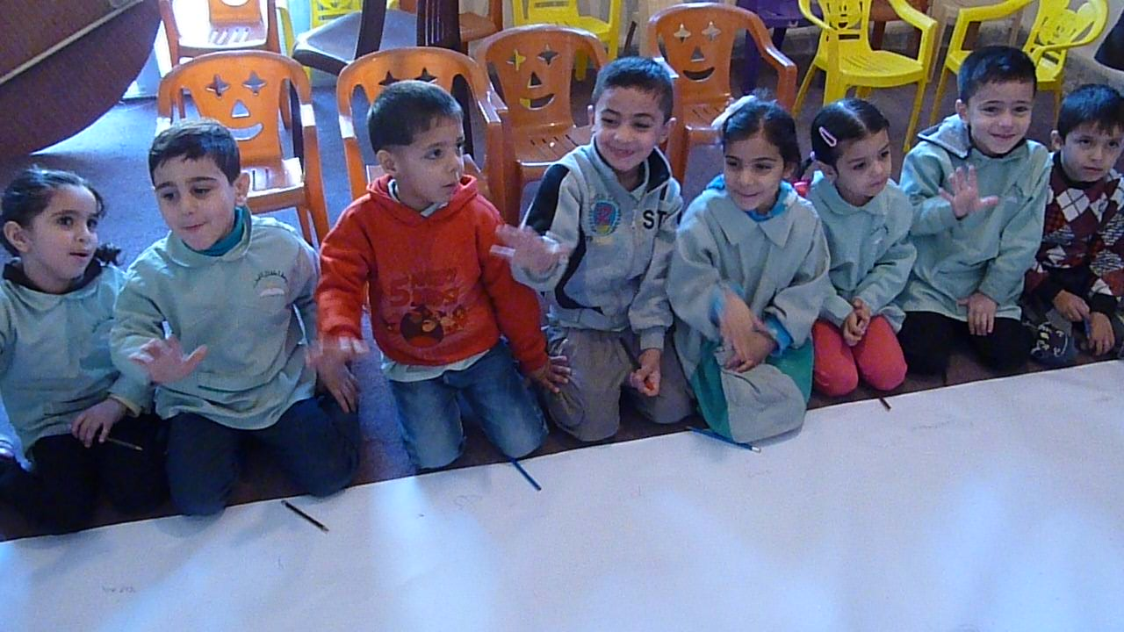
Despite all of these problems, the camp’s children and youth continue to grow
and strive for an education and the development of their full potential.
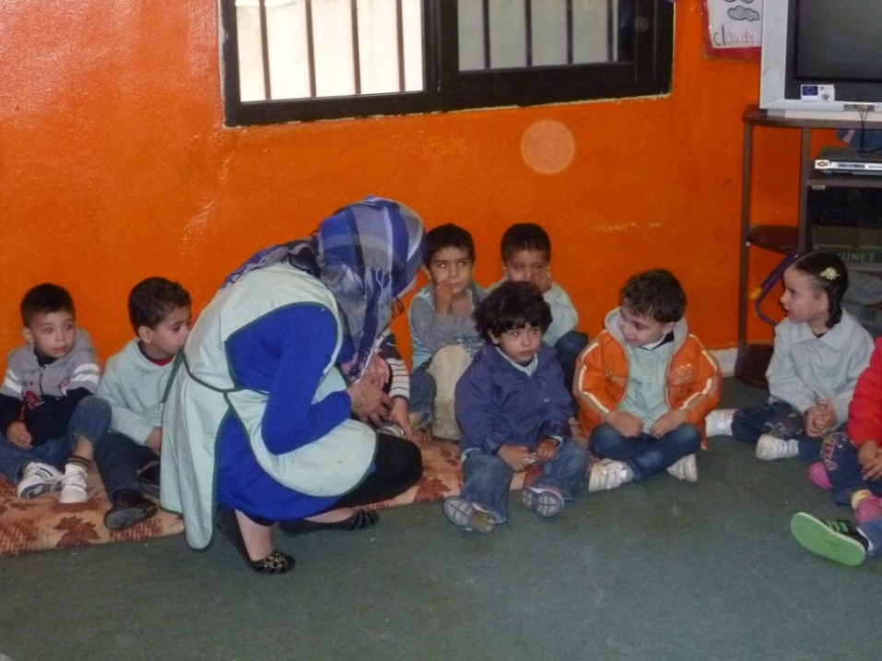
The Children and Youth Center - CYC in the camp has been aiding them in these goals, providing
them with a safe space and quality teachers and facilitators to nourish their minds and bodies.

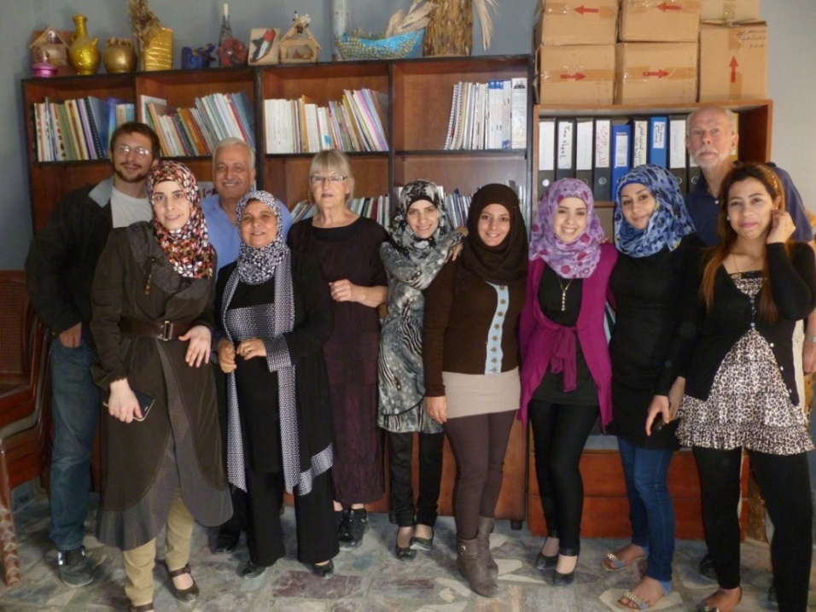
With the help of the center and its range of stimulating activities, comprehensive education
program, and generally positive environment, children and youth of the Nahr el-Bared camp
are able to transcend the hardships of their surroundings and stay on the path of success.

